Backward reduced fixed-effect table:

Degrees of freedom method: Satterthwaite

Eliminated Sum Sq Mean Sq NumDF DenDF F value Pr(>F)

lean_mass 1 7.5580e-10 7.5580e-10 1 59.134 0.0764 0.7832

photoperiod:strain 2 3.9255e-09 3.9255e-09 1 60.297 0.4030 0.5279

photoperiod 3 9.5000e-12 9.5000e-12 1 61.336 0.0010 0.9750

strain 4 4.3549e-09 4.3549e-09 1 62.317 0.4584 0.5009

lipid_mass 5 1.1577e-08 1.1577e-08 1 63.361 1.2298 0.2716

Model found:

tag_mass ~ (1 | batch)

LMER

Fixed effects:

Estimate Std. Error df t value Pr(>|t|)

(Intercept) 0.0008481 0.0001194 4.0830022 7.102 0.00192 **

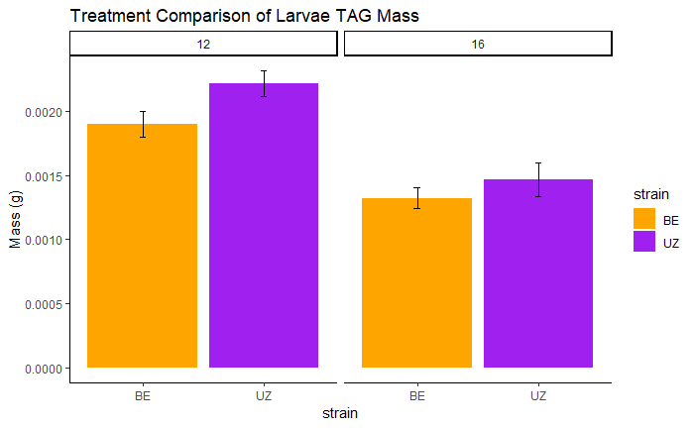

TAG Mass (g)

Short Diapause

Long Diapause

Short Diapause

Long Diapause

**Diapause**

**Non-Diapause**

Backward reduced fixed-effect table:

Degrees of freedom method: Satterthwaite

Eliminated Sum Sq Mean Sq NumDF DenDF F value Pr(>F)

sample_day 1 6.0522e-07 2.0174e-07 3 13.194 0.5592 0.6511

Model found:

tag_mass ~ (1 | rep:batch)

Fixed effects:

Estimate Std. Error df t value Pr(>|t|)

(Intercept) 2.735e-03 2.306e-04 1.781e+01 11.86 6.9e-10 ***

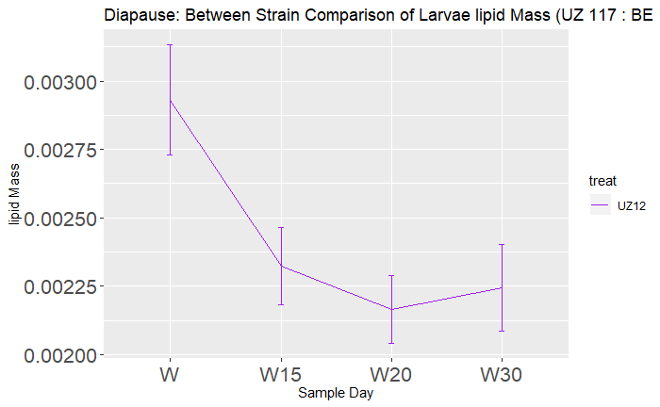

TAG Mass (g)

Wandering

Diapause Day 30

Diapause Day 20

Diapause day 15

**Short Diapause**

**Long Diapause**

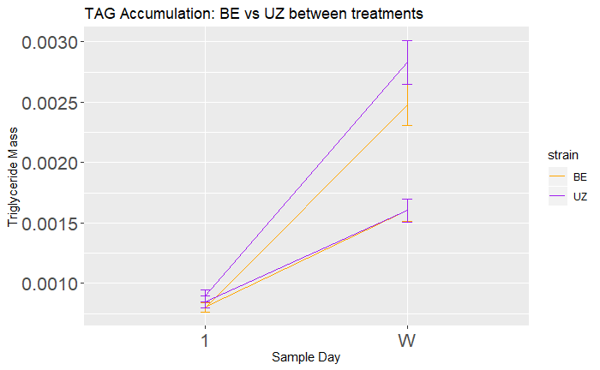

Backward reduced fixed-effect table:

Degrees of freedom method: Satterthwaite

Eliminated Sum Sq Mean Sq NumDF DenDF F value Pr(>F)

photoperiod:strain 1 0.0000e+00 0.0000e+00 1 133.31 0.0009 0.9764925

strain 2 1.0000e-09 1.0000e-09 1 134.84 0.0046 0.9460286

lean_mass 3 4.2600e-07 4.2600e-07 1 141.08 2.6282 0.1072105

photoperiod 0 2.1910e-06 2.1910e-06 1 136.91 13.4357 0.0003522 ***

lipid_mass 0 3.8122e-05 3.8122e-05 1 138.58 233.7684 < 2.2e-16 ***

Model found:

tag_mass ~ photoperiod + lipid_mass + (1 | batch)

Fixed effects:

Estimate Std. Error df t value Pr(>|t|)

(Intercept) 3.984e-04 3.461e-04 1.276e+01 1.151 0.270818

photoperiod16 -3.155e-04 8.609e-05 1.369e+02 -3.665 0.000352 ***

lipid_mass 2.055e-01 1.344e-02 1.386e+02 15.289 < 2e-16 ***

*

**Long Diapause**

**Short Diapause**

Day 1

Wandering

TAG Mass (g)

Backward reduced fixed-effect table:

Degrees of freedom method: Satterthwaite

Eliminated Sum Sq Mean Sq NumDF DenDF F value Pr(>F)

sample_day 1 1.9345e-06 6.4480e-07 3 21.864 1.9311 0.1542438

strain 0 5.0939e-06 5.0939e-06 1 170.901 15.2814 0.0001333 ***

---

Signif. codes: 0 ‘***’ 0.001 ‘**’ 0.01 ‘*’ 0.05 ‘.’ 0.1 ‘ ’ 1

Model found:

tag_mass ~ strain + (1 | rep:batch)

Fixed effects:

Estimate Std. Error df t value Pr(>|t|)

(Intercept) 2.187e-03 1.887e-04 3.139e+01 11.592 7.09e-13 ***

strainUZ 4.247e-04 1.087e-04 1.709e+02 3.909 0.000133 ***

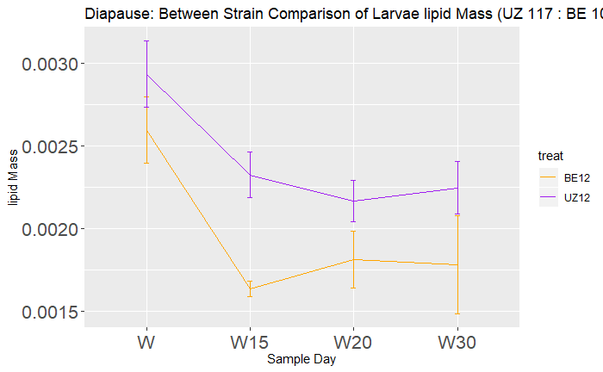

TAG Mass (g)

Wandering

Diapause Day 30

Diapause Day 20

Diapause day 15

**Short Diapause**

**Long Diapause**

*

Backward reduced fixed-effect table:

Degrees of freedom method: Satterthwaite

Eliminated Sum Sq Mean Sq NumDF DenDF F value Pr(>F)

sample_day 0 2.622e-06 8.7401e-07 3 86.258 3.0342 0.03351 *

---

Signif. codes: 0 ‘***’ 0.001 ‘**’ 0.01 ‘*’ 0.05 ‘.’ 0.1 ‘ ’ 1

Model found:

tag_mass ~ sample_day + (1 | batch)

Fixed effects:

Estimate Std. Error df t value Pr(>|t|)

(Intercept) 0.0026366 0.0003847 8.0454051 6.853 0.000127 ***

sample_dayW15 -0.0004287 0.0001671 86.3225828 -2.566 0.012006 *

sample_dayW20 -0.0005015 0.0002929 89.0451303 -1.712 0.090348 .

sample_dayW30 -0.0001647 0.0003424 84.5396948 -0.481 0.631801

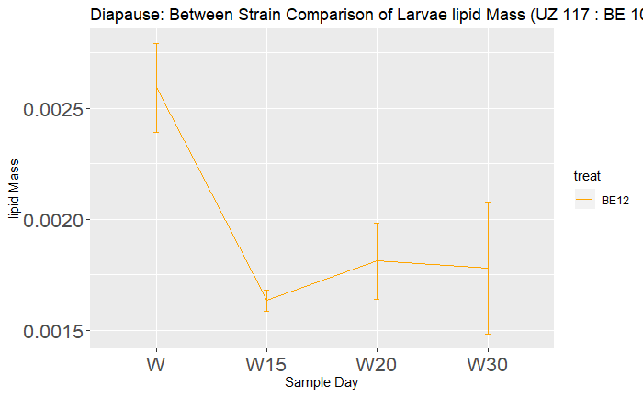

TAG Mass (g)

Wandering

Diapause Day 20

Diapause Day 30

Diapause day 15

**Short Diapause**

**Long Diapause**

*